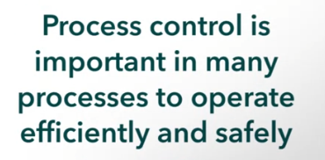

Most common of Process Control:



4 basic components

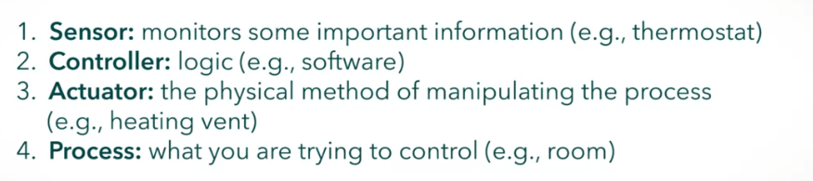

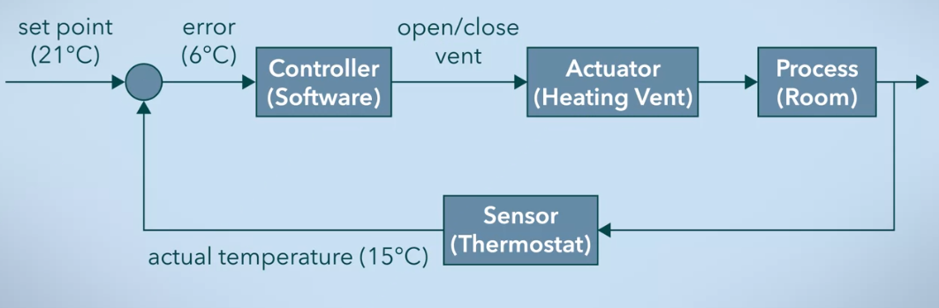

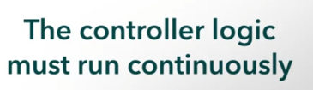

Improvement:

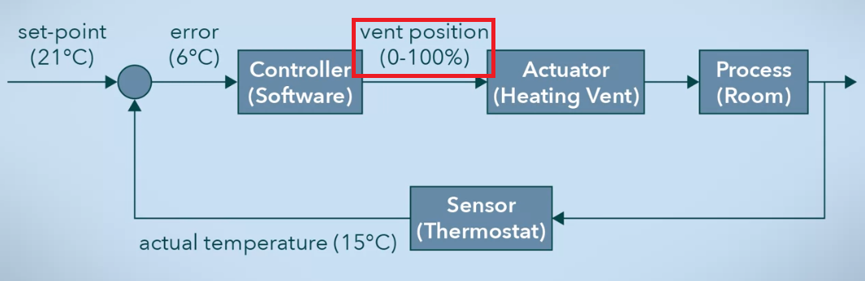

* Proportional controllers

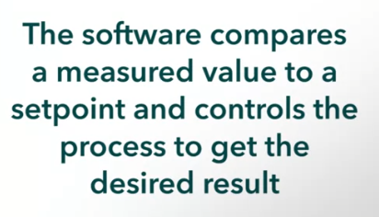

A feedback loop is an example of a **Close** Loop.

Example of **Open** Loop:

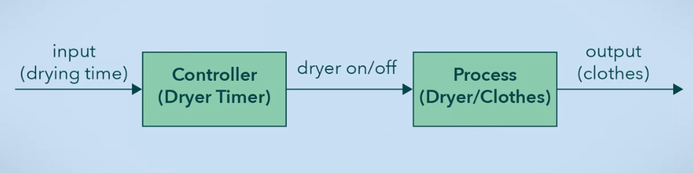

**Feedforward** control loop:

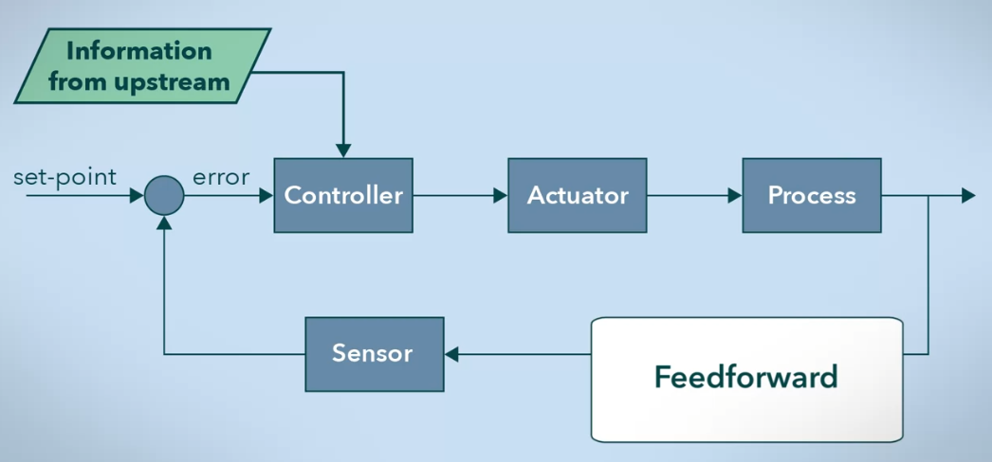

* Proactive response
* In conjunction with feedback loops

Self-driving cars simplified diagram:

